**Experiment Number: 01**

**Problem Statement:** Write Python code to find the statistical properties like- Mean, Median, Mode, Standard Deviation, Variance, Percentile, Data Distribution, Histogram, Big Data Distribution, Normal Data Distribution, Scatter Plot, Random Data Distributions etc.

**NAME:** Harshwardhan Patil  **ROLLNO:** 50

**CLASS:** TY-IT-B **BATCH:** B1

**DATE OF PERFORMANCE: 06/01/2025**

___________________________________________________________________________

PROGARM:  
import numpy as np

import pandas as pd

import matplotlib.pyplot as plt

import seaborn as sns

iris = sns.load_dataset('iris')

mean = iris['sepal_length'].mean()

median = iris['sepal_length'].median()

mode = iris['sepal_length'].mode()[0]

std_dev = iris['sepal_length'].std()

variance = iris['sepal_length'].var()

percentile_25 = np.percentile(iris['sepal_length'], 25)

percentile_75 = np.percentile(iris['sepal_length'], 75)

print("Statistical Properties of 'sepal_length':")

print(f"Mean: {mean}")

print(f"Median: {median}")

print(f"Mode: {mode}")

print(f"Standard Deviation: {std_dev}")

print(f"Variance: {variance}")

print(f"25th Percentile: {percentile_25}")

print(f"75th Percentile: {percentile_75}\n")

fig, axes = plt.subplots(2, 3, figsize=(12, 8))

fig.suptitle("Statistical Analysis and Data Visualization (Iris Dataset)", fontsize=16)

sns.kdeplot(iris['sepal_length'], shade=True, ax=axes[0, 0])

axes[0, 0].set_title("Data Distribution of Sepal Length")

axes[0, 0].set_xlabel("Sepal Length")

axes[0, 0].set_ylabel("Density")

axes[0, 1].hist(iris['sepal_width'], bins=20, edgecolor='k')

axes[0, 1].set_title("Histogram of Sepal Width")

axes[0, 1].set_xlabel("Sepal Width")

axes[0, 1].set_ylabel("Frequency")

sns.histplot(iris['sepal_length'], bins=30, kde=True, ax=axes[0, 2])

axes[0, 2].set_title("Big Data Distribution: Sepal Length")

axes[0, 2].set_xlabel("Sepal Length")

axes[0, 2].set_ylabel("Frequency")

sns.histplot(iris['petal_width'], bins=20, kde=True, ax=axes[1, 0])

axes[1, 0].set_title("Normal Data Distribution: Petal Width")

axes[1, 0].set_xlabel("Petal Width")

axes[1, 0].set_ylabel("Frequency")

sns.scatterplot(x='sepal_length', y='sepal_width', data=iris, hue='species', ax=axes[1, 1])

axes[1, 1].set_title("Scatter Plot: Sepal Length vs Sepal Width")

axes[1, 1].set_xlabel("Sepal Length")

axes[1, 1].set_ylabel("Sepal Width")

axes[1, 1].legend(title='Species')

axes[1, 2].hist(iris['petal_length'], bins=10, edgecolor='k')

axes[1, 2].set_title("Random Data Distribution of Petal Length")

axes[1, 2].set_xlabel("Petal Length")

axes[1, 2].set_ylabel("Frequency")

plt.tight_layout(rect=[0, 0, 1, 0.95])

plt.show()

**OUTPUT: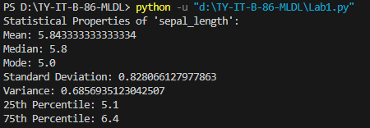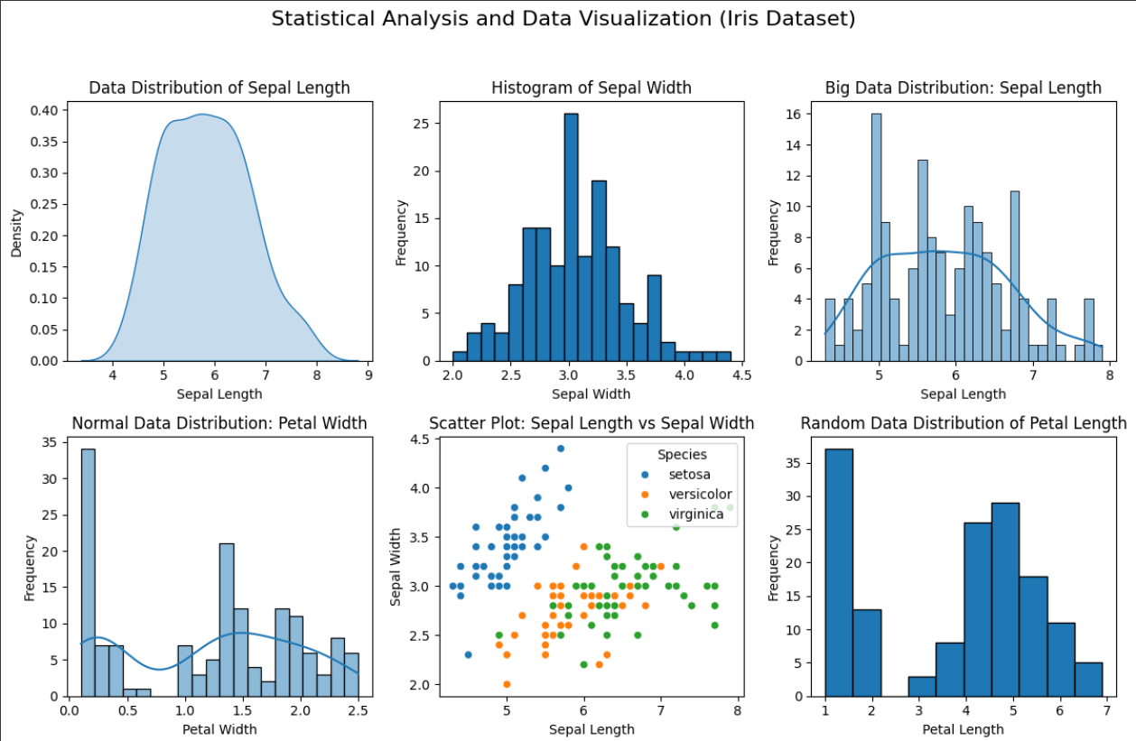 Part 2:**import numpy as np

import matplotlib.pyplot as plt

from scipy import stats

import seaborn as sns

# Sample sentences

sentences = [

"The quick brown fox jumps over the lazy dog.",

"A journey of a thousand miles begins with a single step.",

"To be or not to be, that is the question.",

"All that glitters is not gold.",

"I think, therefore I am.",

"In the middle of difficulty lies opportunity.",

"Success is not final; failure is not fatal: It is the courage to continue that counts."

]

# Function to calculate sentence statistics

def get_sentence_statistics(sentences):

sentence_lengths = [len(sentence.split()) for sentence in sentences] # Number of words per sentence

mean_length = np.mean(sentence_lengths)

median_length = np.median(sentence_lengths)

# Check if mode is a scalar or an array

mode_result = stats.mode(sentence_lengths)

mode_length = mode_result.mode[0] if isinstance(mode_result.mode, np.ndarray) else mode_result.mode # If it's a scalar, assign it directly; otherwise, access the first element

std_dev = np.std(sentence_lengths)

variance = np.var(sentence_lengths)

percentile_25 = np.percentile(sentence_lengths, 25)

percentile_75 = np.percentile(sentence_lengths, 75)

print(f"Mean sentence length: {mean_length}")

print(f"Median sentence length: {median_length}")

print(f"Mode sentence length: {mode_length}")

print(f"Standard Deviation: {std_dev}")

print(f"Variance: {variance}")

print(f"25th Percentile: {percentile_25}")

print(f"75th Percentile: {percentile_75}")

return sentence_lengths

# Get statistics

sentence_lengths = get_sentence_statistics(sentences)

# Data Distribution Plot

plt.figure(figsize=(10, 5))

sns.histplot(sentence_lengths, kde=True, color='skyblue', bins=6)

plt.title("Histogram and Data Distribution of Sentence Lengths")

plt.xlabel("Number of Words")

plt.ylabel("Frequency")

plt.show()

# Big Data Distribution

large_sentence_lengths = np.random.choice(sentence_lengths, 1000, replace=True) # Simulate big data

plt.figure(figsize=(10, 5))

sns.histplot(large_sentence_lengths, kde=True, color='orange')

plt.title("Big Data Distribution (Simulated)")

plt.xlabel("Number of Words")

plt.ylabel("Frequency")

plt.show()

# Normal Data Distribution

normal_dist = np.random.normal(loc=np.mean(sentence_lengths), scale=np.std(sentence_lengths), size=1000)

plt.figure(figsize=(10, 5))

sns.histplot(normal_dist, kde=True, color='green')

plt.title("Normal Data Distribution")

plt.xlabel("Number of Words")

plt.ylabel("Frequency")

plt.show()

# Scatter Plot

plt.figure(figsize=(10, 5))

plt.scatter(range(len(sentence_lengths)), sentence_lengths, color='red')

plt.title("Scatter Plot of Sentence Lengths")

plt.xlabel("Sentence Index")

plt.ylabel("Number of Words")

plt.show()

# Random Data Distributions

random_data = np.random.uniform(low=min(sentence_lengths), high=max(sentence_lengths), size=1000)

plt.figure(figsize=(10, 5))

sns.histplot(random_data, kde=True, color='purple')

plt.title("Random Data Distribution")

plt.xlabel("Number of Words")

plt.ylabel("Frequency")

plt.show()  
  
  
